Ex.No:8 | MINI PROJECT – SOCIAL MEDIA DATA ANALYTICS

AIM:
Social Media Data Analytics using Python, Pandas, Matplotlib, and Exploratory Data Analysis

ALGORITHM:

Step 1: Start the Program
- Start the Python program.
- Import the required libraries such as Pandas, NumPy, Matplotlib, and Seaborn.

Step 2: Load the Dataset
- Read platform_statistics_2026
- Store the data in a DataFrame named df.

Step 3: Create a Working DataFrame
- Create a copy of df.
- Store the copy in platform.
- This allows the original dataset to remain unchanged.

Step 4: Inspect the Dataset
- Display the first few records using head().
- Display the last few records using tail().
- Check the number of rows and columns using shape.
- Display column names and data types.

Step 5: Clean the Data
- Check missing values using isna().sum().
- Identify duplicate records using duplicated().
- Remove duplicate records using drop_duplicates().
- Standardize column names into lowercase and underscore format.

Step 6: Perform Statistical Analysis
- Use describe() to calculate statistical values.
- Find mean, minimum, maximum, and standard deviation.
- Analyze numerical platform statistics such as users, growth, time, and engagement.

Step 7: Filter, Sort and Group Data
- Filter records according to required conditions.
- Sort platforms based on important numerical measures.
- Group the data using suitable categorical fields such as age group, content format, or headquarters country.
- Calculate totals and averages for comparison.

Step 8: Create Visualizations
- Create suitable charts using Matplotlib and Seaborn.
- Generate bar charts, line charts, histograms, box plots, scatter plots, and count plots.
- Create a correlation heatmap for numerical variables.

Step 9: Analyze the Results
- Compare platform performance.
- Identify platforms with higher users, growth, engagement, and daily usage.
- Analyze relationships between numerical variables.
- Identify important trends and patterns from the visualizations.

Step 10: Display and Store the Final Results
- Display the cleaned dataset and analysis results.
- Save the cleaned platform dataset if required.
- Use the cleaned data for Power BI/Tableau dashboard development.
- Present the final insights.
- Stop

PROGRAM:

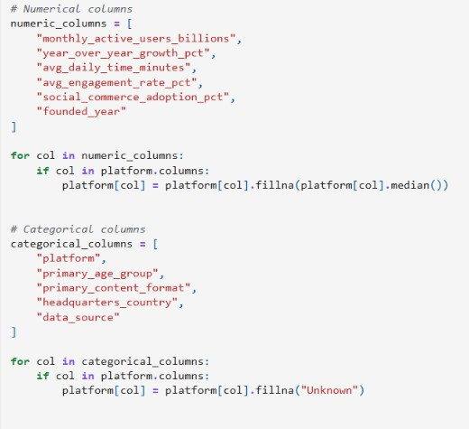

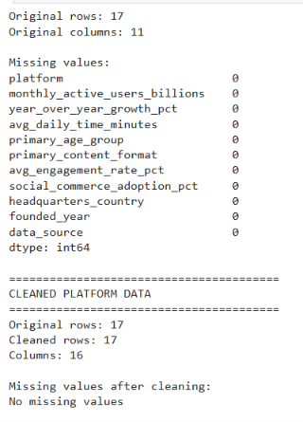

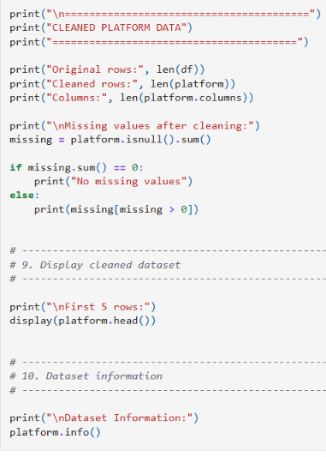
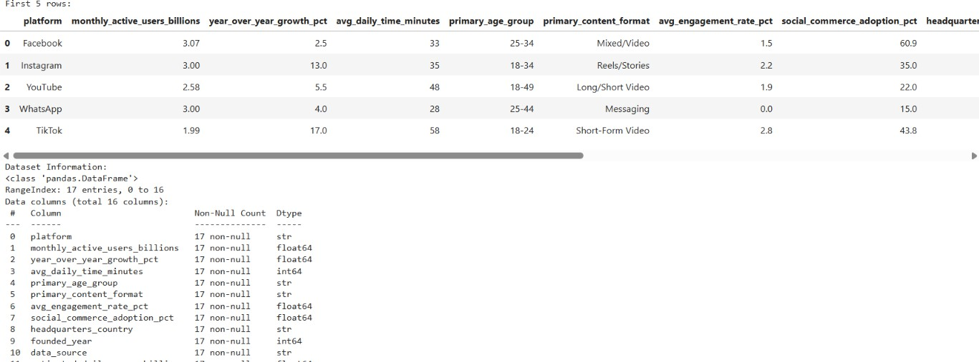

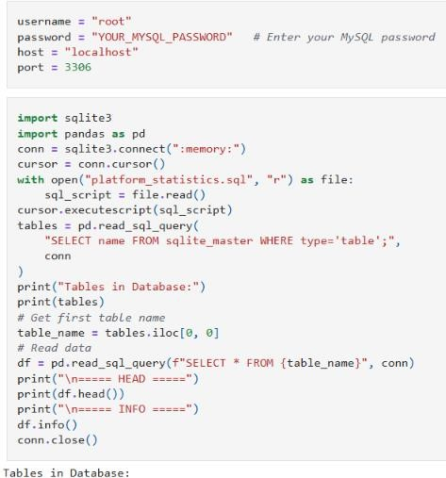

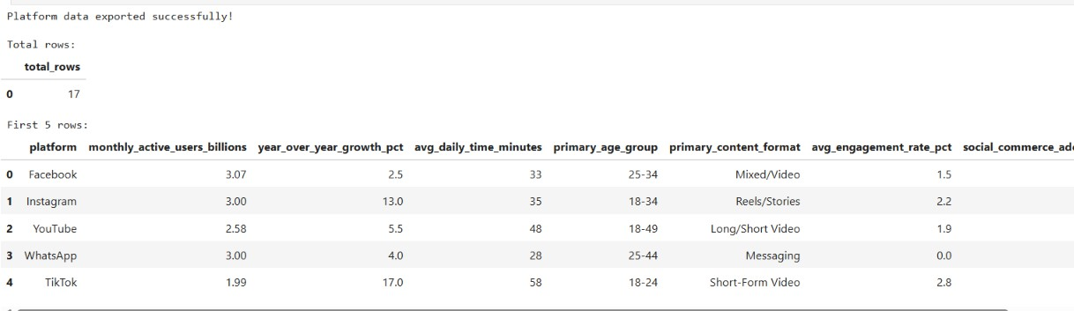
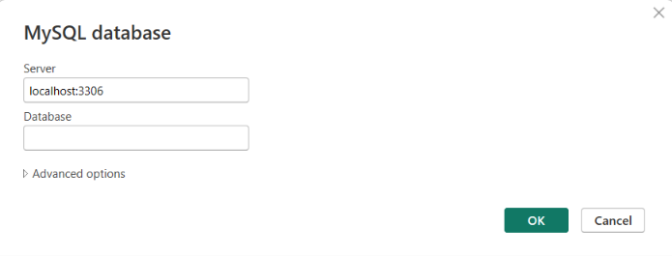

POWER BI:
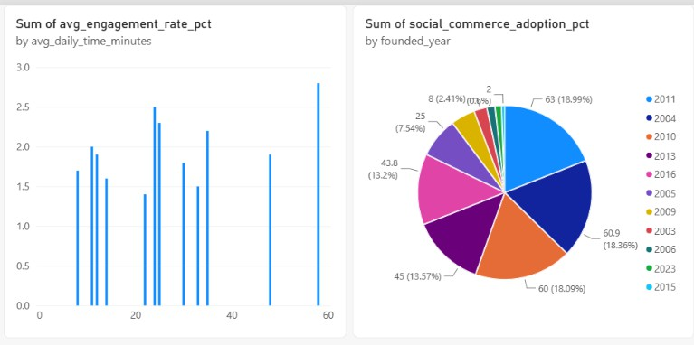

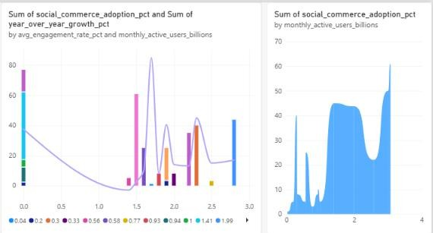

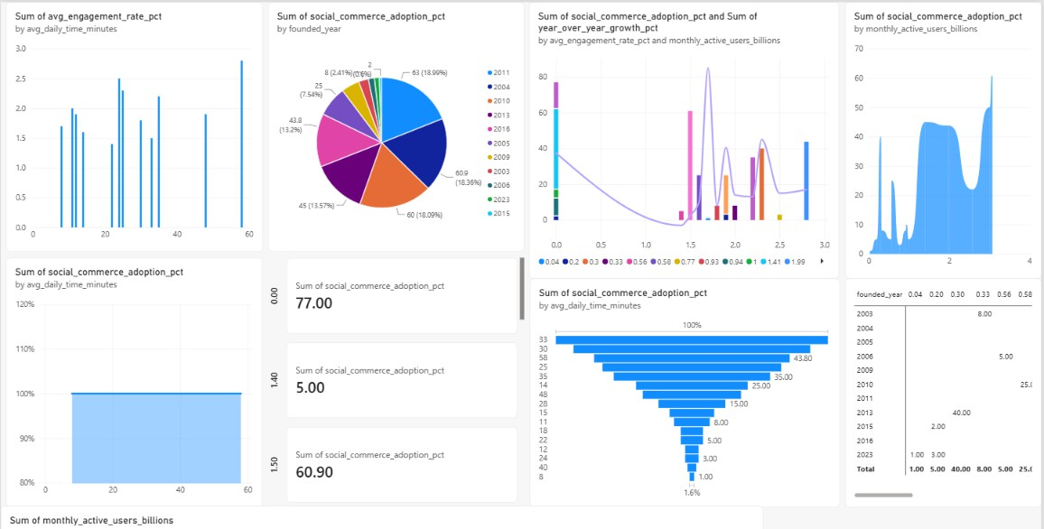

TABLEAU:
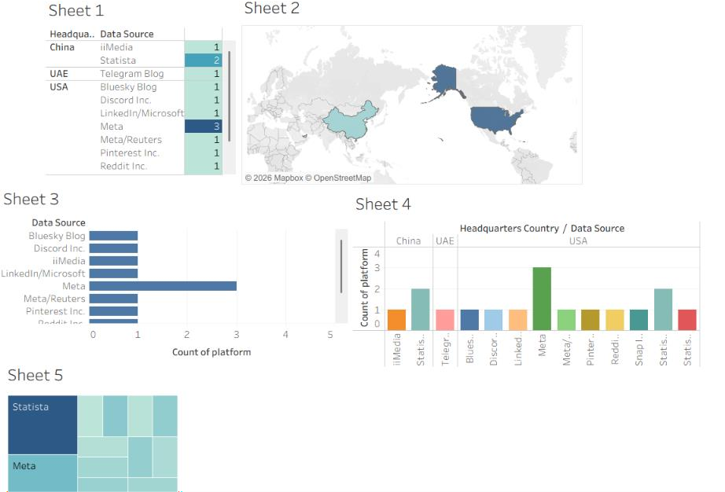
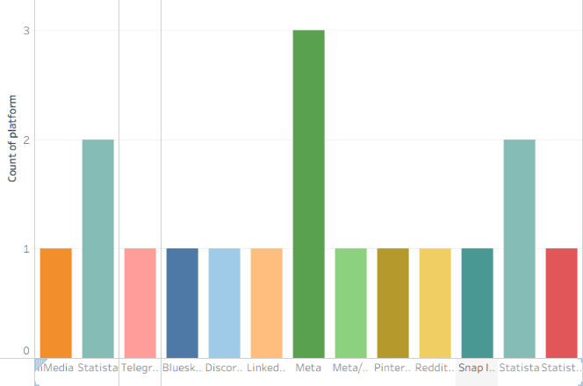
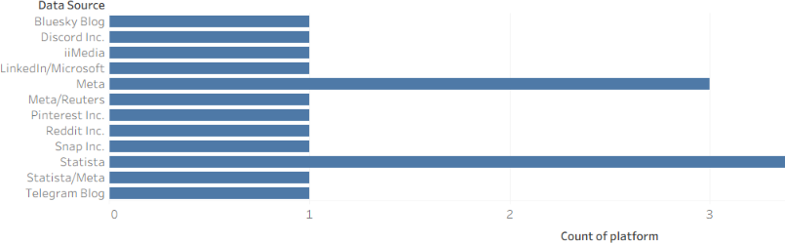

RESULT:
Thus the data visualization was successfully completed in Jupyter, Power BI, Tabelu

